7 set of 20 minute data were taken.

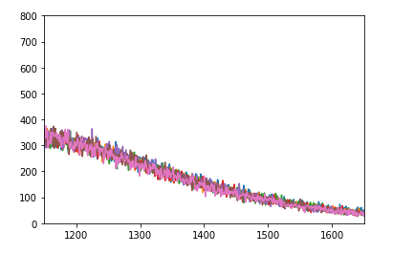

Based on above plot range of value for comparison was selected from 1150 to 1650. Why do we take linear region – You told me something about compton scattering but not completely clear to me.

Statistical uncertainty has increased – 4.26%
Systematic uncertainty has also increased – 3.84%
----------------------------------------------------------------------------------------------------------------------

